Project Design Phase
Solution Architecture

Date | 25 September 2026
Team ID | 6ab4bfd66f290be8a6b41582
Project Name | AI BlogNest API
Maximum Marks | 4 Marks

Solution Architecture:
Solution architecture is a complex process – with many sub-processes – that bridges the gap between business problems and technology solutions. Its goals are to:
- Find the best tech solution to solve existing business problems.
- Describe the structure, characteristics, behavior, and other aspects of the software to project stakeholders.
- Define features, development phases, and solution requirements.
- Provide specifications according to which the solution is defined, managed, and delivered.

Solution Architecture Diagram – AI BlogNest API:

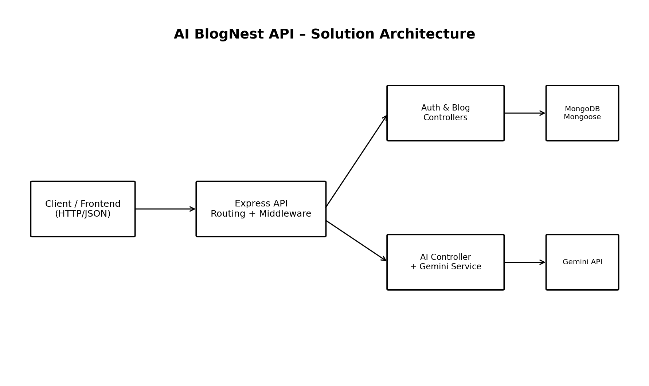
Figure 1: AI BlogNest API solution architecture
Architecture Layers:
Layer | Responsibilities | Relevant Project Files
Server / Entry | Loads environment variables, connects to MongoDB and starts the HTTP server. | src/server.js
Application / Express | Creates Express application, registers middleware and routes. | src/app.js
Routes | Maps HTTP methods and paths to controllers and validation rules. | src/routes/*.js
Middleware | Authenticates Bearer JWT tokens and handles application errors. | src/middleware/*.js
Controllers | Implements registration, login, profile, blog CRUD, generation and summarization workflows. | src/controllers/*.js
Service | Encapsulates the Gemini API integration. | src/services/geminiService.js
Models / Persistence | Defines User and Blog schemas and database relationships. | src/models/*.js
External Services | MongoDB stores persistent data; Gemini provides AI-generated text. | MongoDB / Google Gemini
Request Flow:
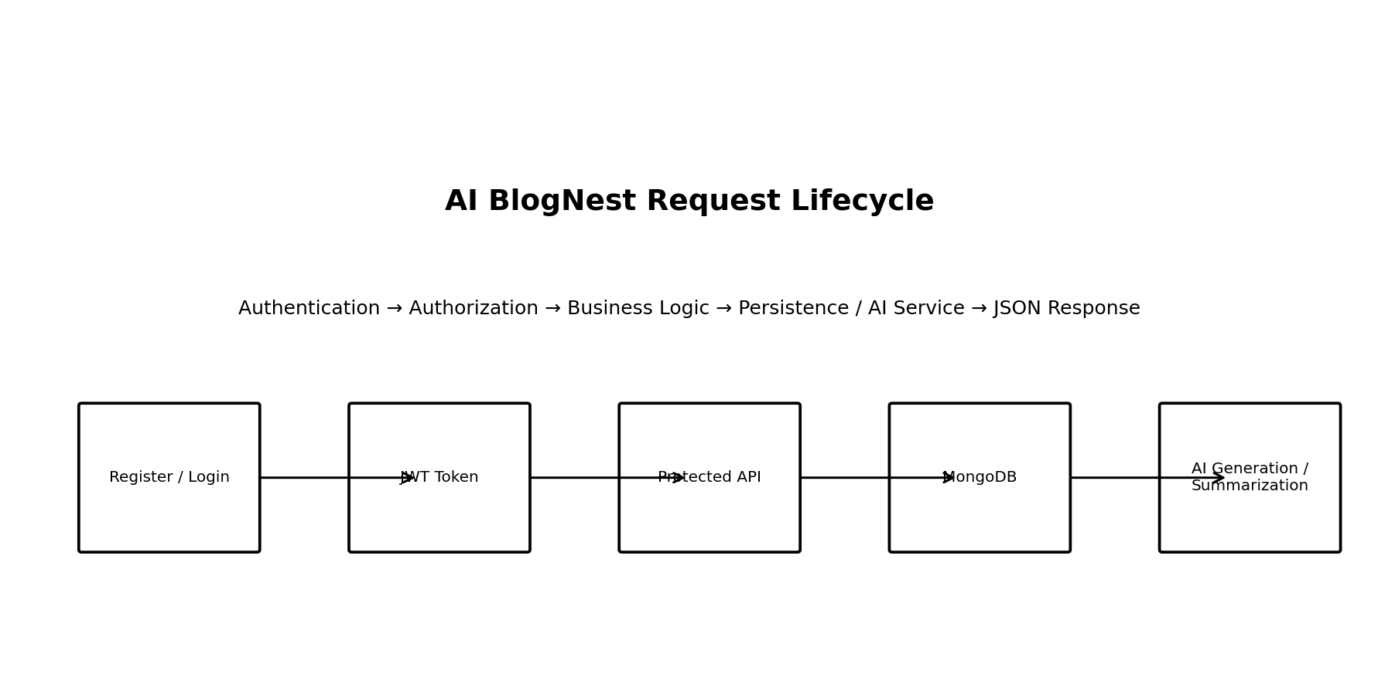
Figure 2: Typical AI BlogNest request lifecycle
Authentication and Authorization Flow:
Step | Description
1 | User registers using name, email and password.
2 | The server checks whether the email already exists and hashes the password using bcrypt.
3 | User logs in with email and password.
4 | The server verifies the password and issues a JWT with a seven-day expiry.
5 | Protected routes read the Authorization: Bearer <token> header.
6 | The middleware verifies the token and loads the corresponding user without the password field.
7 | Controllers perform the requested operation and return JSON.

